SJK (C) HUA HSIA
峇眼拿督华夏华文小学
TRIAL UPSR of 2018
English Year 6 (Writing)
Time:1 Hour 15 Minutes

There are three sections in this paper: Section A, Section B and C. Answer the questions in all the sections. For Section C, you can choose to answer Question 1 or Question 2.
Section A (10 marks)
Read the leaflet below and use the information to complete the following text.
FUN HOLIDAY PROGRAMME AT JOY TUITION CENTRE

21 November- 22 December
- Speaking English in Fun Class
- English Drama Class
- Computer Art Class
- Language games
- Treasure hunts
20% discount for early birds!

Fun and interesting ways to master English…

1
Based on the leaflet complete the message below.

Dear mum and dad,
I wish to improve my English. I came across this leaflet on (1)_________________________________________. It is run by Joy Tuition Centre. They offer (2)________________________________________________ to master English. The duration of the course is (3)________________________________________. The activities look interesting and innovative. They have speaking English in Fun Class, (4)____________________________________ ________________________________ and Computer Art Class. If we register early, we can (5)_______________________________. I hope to get your permission to join this programme
1
Love
Lovisa
Section B(i)
Study the flyer below and answer the question that follows in the space provided.
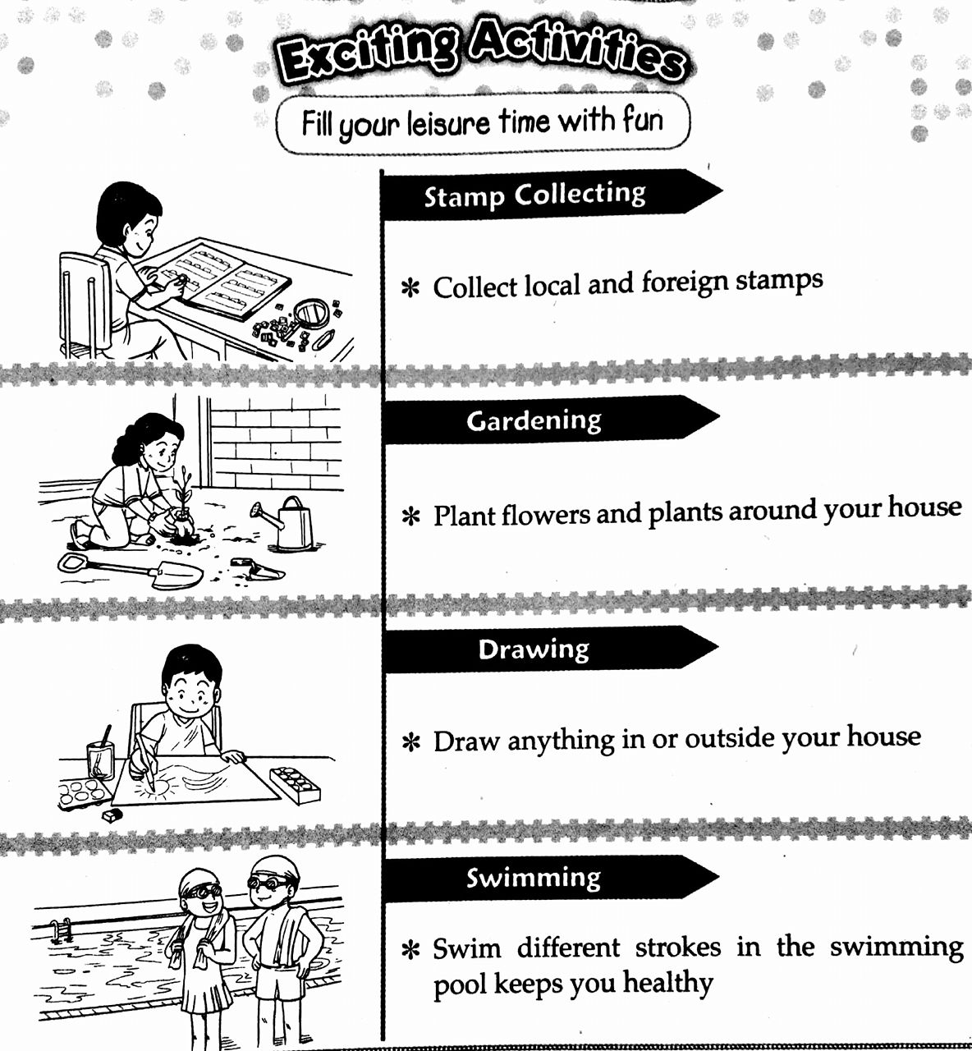

Stamp collecting

Collect local and foreign stamps

Gardening

Plant flowers and plants around your house
2

Drawing

Draw anything in or outside your house

Swimming

Swim different strokes in the swimming pool to keep you healthy

2
List three activities that you can do during your free time.

(a)_________________________________________________________________________________

(b)_________________________________________________________________________________

(c)_________________________________________________________________________________
(3 marks)

Section B (ii)

Gardening Competition
Venue: Roy Botanic
Venue: Garden Mall
Stamps collecting Competition

- Beautify your house
- Get to learn more about gardening.
- Gain extra knowledge
- Get to know new friends

Tools needed: spade, trowel, watering cans and gloves
Tools needed: stamps albums, magnifying glass and stamp tongs

Swimming Competition
Venue: SK Sumun
Drawing Competition
Venue: Rejoy pool

- Stay fit and healthy
- Release stress
- Boost creativity.
- More imaginative.

Tools needed: goggles, swimming caps, swimsuit and towels
Tools needed: pencils, sketchbook, eraser, sharpener, coloured pencils or water colours

Your friend is coming to visit you during the school holidays. You would like to participate in a competition with him/her. Based on the flyer, write a letter telling him/her about the benefits of the competition and what to bring. Your letter should be between 50 and 80 words.
3
3

Section C (25 marks)

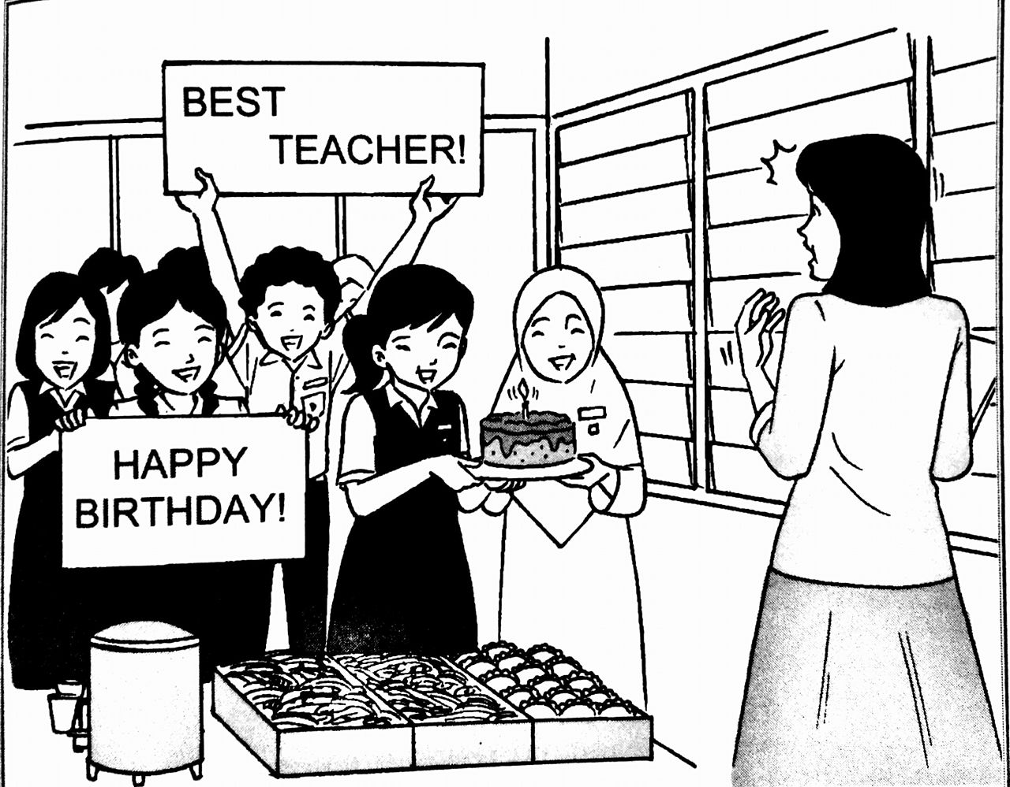
Question 1: Write a story based on the picture below. You may use the words given to help you. Write your answer in the space provided. Write your story between 80 and 100 words.

surprise party divided decorated cake
prepared invited sang surprised
impressed memorable

Begin your story with:
Madam Chen’s birthday was around the corner. The class monitor of 6 Bestari suggested …

4

OR
Question 2
Write a short story based on the pictures below. You may use the words given to help you. Write your answer in the space provided. Your story must between 80 and 100 words.

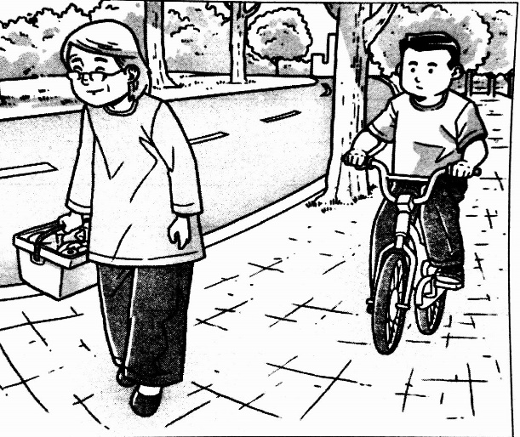

-cycling –old lady-walking-slowly
-heavy-stopped

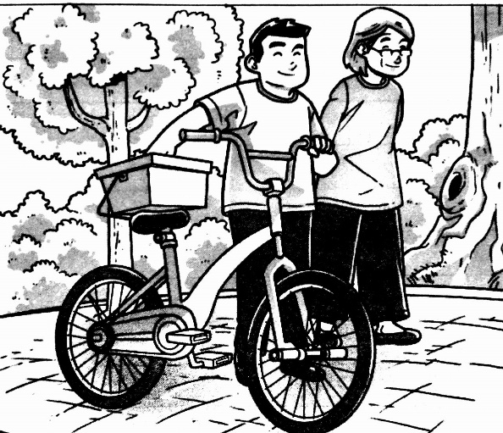

--put - on the seat- pushed-
-bicycle-walked

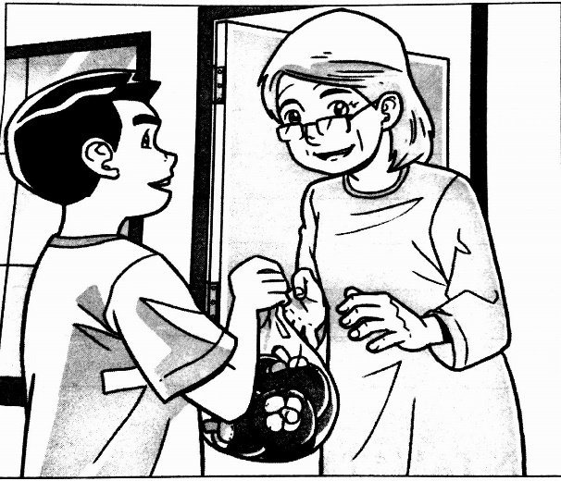

- -reached- thanked-kindness
-appreciated-mangosteens-home

Prepared by: Tan Siang Ying Verified by: Ong Kok Leong
5

